

WeatherBug Backyard Stations Publishing API
Version 1.4
3/4/2011
Information Document

System Overview
The WeatherBug Backyard Stations Publishing API allows any software developer to send weather data from Backyard Stations to the WeatherBug Network and Archive to be displayed on its web site and other associated properties.

The API includes the following:
- A registration and site status URL (Web Site) call so that the end user can create a Publisher ID to identify the Backyard Station site, to gather user contact information as well as the Backyard Station location information.
- A live data URL (API) call so that the end user can send live weather information from a Backyard Station to our data centers. This live data is intended to be changing and transitory and is not stored historically in our data centers.

API Calls
The following are the API calls to register your Backyard Station and to update weather information.

Registration and Station Status

Registration URL
http://reg.backyard.weatherbug.com/Reg/PWSRegPage.aspx?@Password=weatherbug&@StationID=p02073&@StationNum=13669&@Partner=WxPartner

The registration page should be called with the following parameters.

@Partner=WxPartner : This will allow WeatherBug to identify the partner we are working with to display specific instructions for your software. Please email us at pws@weatherbug.com to make sure we agree on a partner ID.
@password=weatherbug: This is the station password the user entered during the registration process. This parameter is optional if you do not want to include it for security purposes. They will be asked for their password to gain access to their information.
@StationID=p02073 : This is the Publisher ID assigned to the user when they registered.
@StationNum = 13669 : This is the station number assigned to the user after they registered their site.
All of these parameters should be passed to the registration form so that the user can return to that page and EDIT their registration form later on if they desire. Initially when it is the user’s first registration these values will all be blank except for the @Partner parameter, which is based on your software. The following figure shows an example of the registration screen.

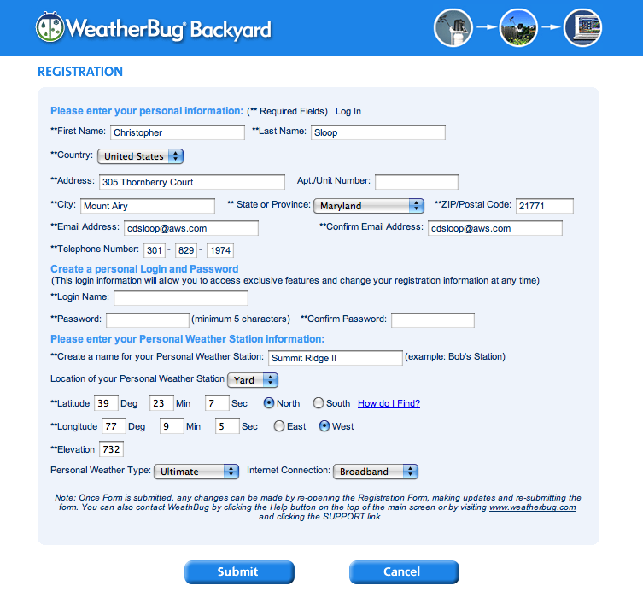

The following figure gives an example of what the registration form looks like after the user has entered all their information.
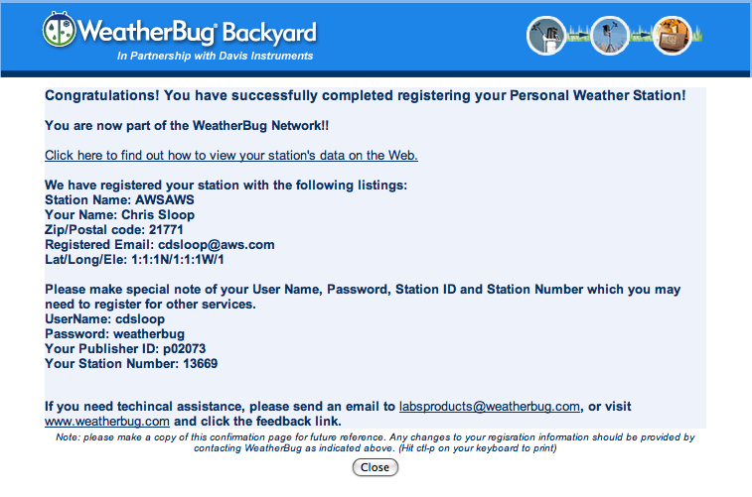

Status Page

Once a user registers their Backyard Station, they will want to visit a page that gives them information about the status of their station and whether it is reporting properly or not. This page is currently a “work in progress”.

The URL of the status page should be called as follows:
http://data.backyard2.weatherbug.com/data/ecv.aspx?ID=p01717&NUM=4076&Partner=WxPartner

ID = Publisher ID
NUM = Station Number
Partner = your partner ID which you have agreed to use.

I plan to add many capabilities to this page including special free offers to users that have been sending us data for a long time.

Please direct end users to this page for status of their site sending data.

Posting Live/Current data

Option 1: (QueryString Based Protocol)

HTTP Querystring Parameters...

Required Parameters
- action [action=live] Indicates that this is current data [action=hist] Indicates this is historical data.
- ID [Station ID as registered above]
- Key [your self assigned PASSWORD associated with this Station ID]
- Num [This is the StationNum element from above]
- dateutc - [YYYY-MM-DD HH:MM:SS (mysql format)]
- winddir - [0-360]
- windspeedmph - [mph]
- windgustmph - [windgustmph ]
- humidity - [%]
- tempf - [temperature F]
- rainin - [rain in (hourly)] -- the accumulated rainfall in the past 60 mins
- dailyrainin - [rain so far today in localtime]
- baromin - [barom in]
- tempfhi – [high for today in deg F]
- tempflo – [low for today in deg F]
- monthlyrainin – accumulated rain so far this month.
- Yearlyrainin – accumulated rain so far this year.

Optional parameters
If there are additional temperature and humidity sensors then they can be sent as tempf2, tempf3, humidity2, humidity3, etc. temp2desc can be sent as a description of what the temperature represents (ie, water or soil or other).

- dewptf- [dewpoint F] this is already calculated from temp and humidity.
- weather - [text] -- metar style (+RA)
- clouds - [text] -- SKC, FEW, SCT, BKN, OVC
- soiltempf - [temp F]
- soilmoisture - [%]
- leafwetness - [%]
- solarradiation - [MJ/m^2]
- UV - [index]
- visibility - [nm]
- softwaretype - [text] ie: vws or weatherdisplay

Example Call:
http://data.backyard2.weatherbug.com/data/livedata.aspx?ID=P000001&Key=XXXXXX&num=xxxx&dateutc=2000-01-01+10%3A32%3A35&winddir=230&windspeedmph=12&w
indgustmph=12&tempf=70&tempfhi=81&tempflo=50&rainin=0&baromin=29.1&dewptf=68.2&humidity=90
&weather=&clouds=&softwaretype=vws%20versionxx

Option 2:

Make http call to POST the Live data.

http://data.backyard2.weatherbug.com/data/livedata.aspx

The data post information is included in the WXAPI.cpp and WxAPI.h files which are part of the Zip file included with this documentation.

The WxAPI class has included in it all possible data elements to be set as well as capability to post the data to the web site.

Example:

myWxAPI WxAPI;
myWxAPI.SetStationParameters(StationNum, “ID”, “Password”);
myWxAPI.outdoortemp=45;
myWxAPI.humidity=33;
etc….
CString theResponse;
theResponse = myWxAPI.PostLiveWeatherData();

